

Mini Project Report
of
Database Systems Lab (CSE 2262)

Online Shop

SUBMITTED
BY

M.V.Balaji-210905400 Roll No. :60
Varun Sathaye-210905105 Roll No. :17

Department of Computer Science and Engineering
Manipal Institute of Technology, Manipal.
April 2023

DEPARTMENT OF COMPUTER SCIENCE & ENGINEERING

Manipal
00/00/2023

CERTIFICATE

This is to certify that the project titled Online Shopping Website is a record of the bonafide work done by M.V.Balaji, Varun Sathaye (Reg. No. 210905400,210905105) submitted in partial fulfilment of the requirements for the award of the Degree of Bachelor of Technology (B.Tech.) in COMPUTER SCIENCE & ENGINEERING of Manipal Institute of Technology, Manipal, Karnataka, (A Constituent Institute of Manipal Academy of Higher Education), during the academic year 2022-2023.

Name and Signature of Examiners:

﻿
- Dr. Anup Bhat, Assistant Professor, CSE Dept.

- Mr. Govardhan Hegde, Assistant Professor Selection Grade, CSE Dept.

TABLE OF CONTENTS

ABSTRACT

CHAPTER 1: INTRODUCTION

CHAPTER 2: PROBLEM STATEMENT & OBJECTIVES

CHAPTER 3: METHODOLOGY

CHAPTER 4:ENTITY RELATIONSHIP MODEL

CHAPTER 5: DML AND DDL COMMANDS

CHAPTER 6: RESULTS & SNAPSHOTS

CHAPTER 7: CONCLUSION

CHATER 8:LIMITATIONS & FUTURE WORK

CHAPTER 9: REFERENCES

ABSTRACT

The online shop is a platform that allows customers to browse and purchase products from the comfort of their own home. The, customers can sign up for a new account by providing their name, email address, and password. Once registered, customers can log in to the platform and browse products by category, title, or price. This website has multiple product organized into multiple categories which make the shopping process simple and convenient, and customers can add products to their shopping cart to and checkout complete their order. In addition, the website allows customers to view their order history, track the status of their orders, and receive updates on the latest promotions and discounts. The online shop is designed to be secure and reliable, with measures in place to protect customer data and ensure a smooth shopping experience. With its wide selection of products, convenient features, and easy-to-use interface, the online shop is an ideal destination for anyone looking to buy products online.

CHAPTER 1: INTRODUCTION

As e-commerce experiences remarkable growth around the world, online retail application databases are among the most in - demand applications for user-seller interaction across the world. Today, E-commerce applications thrive to connect people to sellers to buy products of their desire and comfort.

The application allows the customer to register and to select and buy items from different product categories .

Schema:
Category(category_id,category_title)
Product(product_id,category_id,product_title,product_desc,product_key, product_img,product_price,date)
Cart_Details(product_id,quantity)
User(user_id, username,user_email,user_password,user_address,user_mobile)
Order_Details(order_id,user_id,amount,invoice,total_products,order_date)

Features:
- Create new user
- Add Product to Cart
- Update/Remove Products from Cart
- Checkout Items from Cart
- Fetch User Order History
- Admin can add new categories
- Admin can add new products inside categories

CHAPTER 2: PROBLEM STATEMENT & OBJECTIVES

Problem Statement:
Design and implement a simple marketplace where items can be listed for sale or for purchase under various categories.

Objective:
The online shop is a platform that allows customers to browse and purchase products from the comfort of their own home. The, customers can sign up for a new account by providing their name, email address, and password. Once registered, customers can log in to the platform and browse products by category, title, or price. This website has multiple product organized into multiple categories which make the shopping process simple and convenient, and customers can add products to their shopping cart to and checkout complete their order. In addition, the website allows customers to view their order history, track the status of their orders, and receive updates on the latest promotions and discounts. The online shop is designed to be secure and reliable, with measures in place to protect customer data and ensure a smooth shopping experience. With its wide selection of products, convenient features, and easy-to-use interface, the online shop is an ideal destination for anyone looking to buy products online.

CHAPTER 3: METHODOLOGY

Protocols Used:

PHP:

PHP is a general-purpose scripting language geared toward web development. It was originally created by Danish-Canadian programmer Rasmus Lerdorf in 1993 and released in 1995. PHP is a server scripting language, and a powerful tool for making dynamic and interactive Web pages.PHP is a widely-used, free, and efficient alternative to competitors such as Microsoft's ASP.PHP can be used for many programming tasks outside the web context, such as standalone graphical and databases applications .

MySQL:

MySQL is a widely used relational database management system (RDBMS). MySQL is free and open-source. MySQL is ideal for both small and large applications. A relational database organizes data into one or more data tables in which data may be related to each other; these relations help structure the data. SQL is a language programmers use to create, modify and extract data from the relational database, as well as control user access to the database.
MySQL has stand-alone clients that allow users to interact directly with a MySQL database using SQL, but more often, MySQL is used with other programs to implement applications that need relational database capability. MySQL is a component of the LAMP web application software stack (and others), which is an acronym for Linux, Apache, MySQL, Perl/PHP/Python.

Firstly,we decided on our database design by design an entity relationship model.Using the ER Model we derived the schema.We added all the tables from the schema to our database.Following that we designed user login/register and product/category GUI elements and linked it to the database and inserted all the data in the database.Once that was done Homepage and Cart elements were designed and were linked with the database.Lastly we implement user order logic and linked it to the database.

CHAPTER 4: ENTITY RELATIONSHIP MODEL

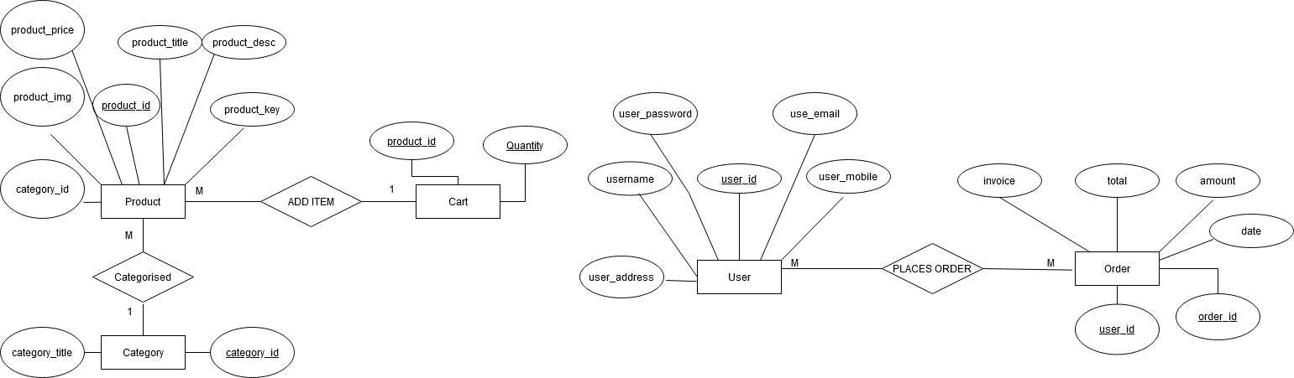

CHAPTER 7: CONCLUSION

In conclusion, the project has been developed by using PhP and MySQL where we showcase on online store that meets customers and sellers’ needs.

The rise of online marketplaces and e-commerce stores has revolutionized the way we shop. The ability to list and sell items online has opened up a whole new world of possibilities for both consumers and businesses alike. By providing a platform for sellers to showcase their products, and buyers to browse and purchase items from the comfort of their own homes, these marketplaces have become an integral part of modern commerce.

Purpose of using MySQL:
- Ease to customise or alter data
- Economical
- Easy to implement and design a database

Purpose of using PhP:
- Easy to write back end code
- Platform independent
- .Easy to load applications and connect to database

CHAPTER 8: LIMITATIONS & FUTURE WORK

There are several possible limitations of our online marketplace project for a database system, including:

- Scalability: As an online marketplace grows, so does the amount of data it needs to store and manage. This can put a strain on the database system and lead to performance issues if it's not designed to handle large volumes of data.

- Security: Online marketplaces deal with sensitive customer information such as personal and financial data, making them attractive targets for hackers. Without proper security measures in place, a database system can be vulnerable to breaches and data theft.

- Data consistency: In an online marketplace, multiple sellers may be selling the same item, and it's important to ensure that the data related to each item is consistent across the platform. Any discrepancies in the data can lead to confusion and distrust among buyers.

4. Maintenance and updates: A database system requires regular maintenance and updates to ensure optimal performance and security. Without proper maintenance, the system can become slow, unstable, or even crash.

Overall, while our online marketplace project displays its functioning and systems properly, there are also several limitations to consider when building and maintaining a database system for them. It's important to carefully plan and design the system to address these limitations and ensure a smooth and secure user experience.

To ensure the smooth functioning of an online marketplace project and address the limitations of the database system, the following measures can be taken:

1. Scalability: One way to tackle scalability issues is to use a distributed database system that can handle large volumes of data across multiple servers. Additionally, employing caching techniques and optimizing queries can help improve performance.

2. Security: To improve security, the database system should be designed with strong encryption, access controls, and regular vulnerability assessments. Regular backups of the database can also help minimize data loss in case of a breach.

3. Data consistency: Ensuring data consistency across the platform can be achieved through the use of unique identifiers for each item and implementing a system for verifying and reconciling data.

4. Maintenance and updates: Regular maintenance and updates of the database system should be scheduled to ensure optimal performance and security. Automated tools and monitoring systems can also help identify issues and address them in a timely manner.

CHAPTER 9: REFERENCES

- https://www.geeksforgeeks.org
- https://www.tutorialspoint.com
- https://www.w3schools.com
- www.php.net

